**How much money do you need??**

You have just graduated from university and you and your friends are discussing where you would like to be in 10 years’ time.

So, where would you like to be living? Pick your house.

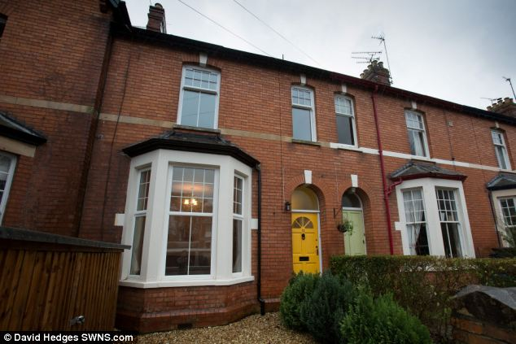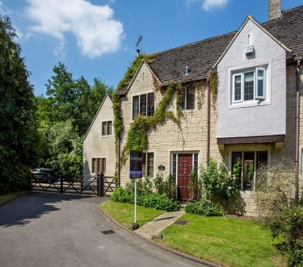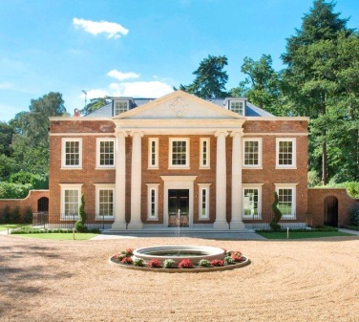

**C**

**B**

**A**

£1,000,000 £500,000 £250,000

40% deposit + 60% Mortgage 15% deposit + 85% Mortgage 10% deposit + 90%Morgage

1. Work out how much deposit and how much mortgage you will need.
2. The mortgage is spread over 25 years, at 4% interest. Work out how much you would need to pay back monthly.
3. Decide the percentage you of your salary you would want to spend of each of the topics below:

Mortgage Food Bills Savings Entertainment

1. Using how much money you need to spend on your mortgage and the percentage of your salary you allocated to this, calculate how much you would need your total salary to be, and how much you would have to spend on each of the other categories.

Now consider your deposit. Whilst you are saving up, you will need somewhere to live. Pick your flat:

**B**

**A**

**C**

At home with parents, Outskirts of a city London Flat share

£100 pm contribution (1 hour commute) £800 per month

£500 per month

Split your monthly salary into the following categories again:

Rent Food Bills Savings Entertainment

1. Work out how much you need to earn to pay your rent, and how much you will save using the percentages.
2. How long will it take you to save your deposit?
3. Considering the annual graduate salary is £24,000 before tax, is this feasible?

Tax is calculated using the following information:

£10,000 tax free, 20% for the next £32,000. 40% for the next £120,000.